Yoshika r.e-192221102

CSA0783-computer networks

**Experiment -13:-** IOT Devices in Networking Using Cisco Packet Tracer

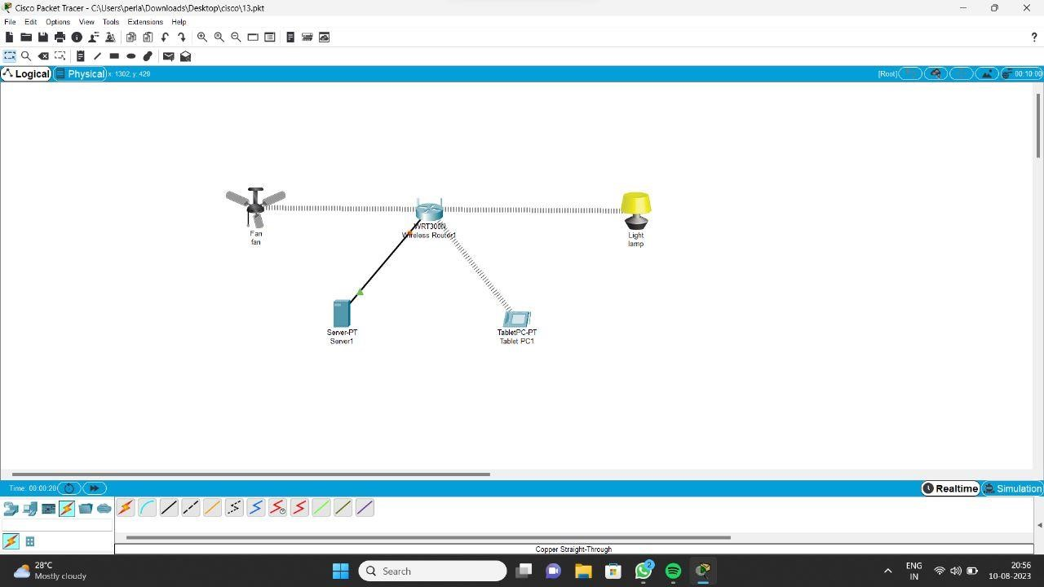

**Experiment 14 :-** Simulating X,Y,Z Company Network Design

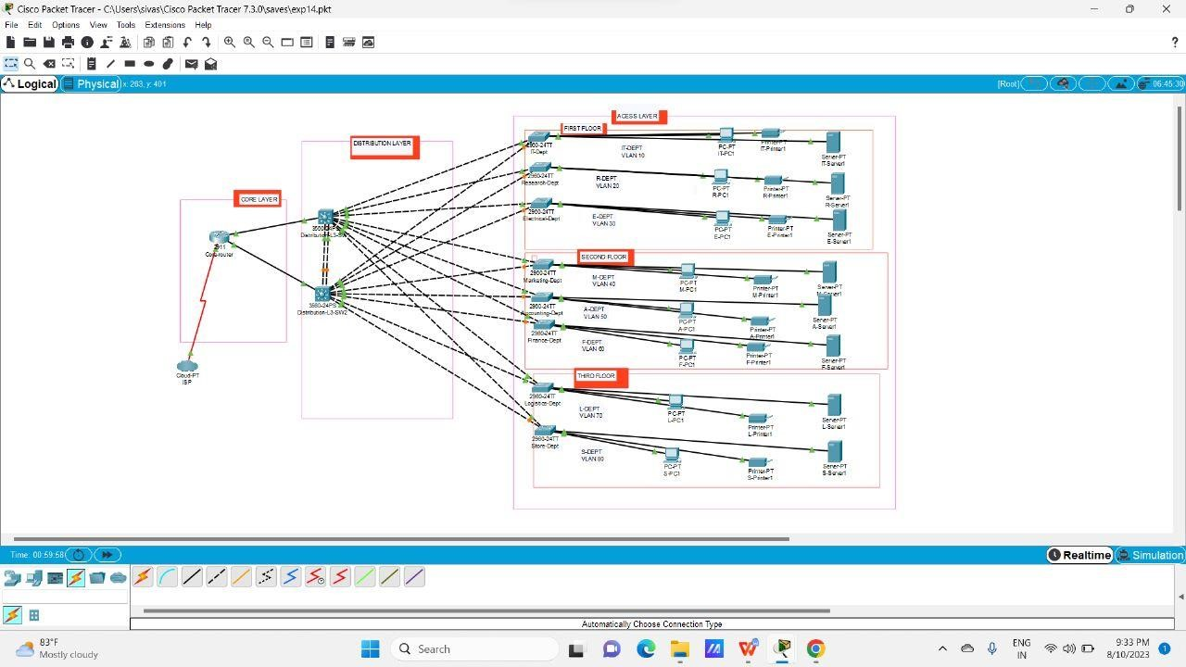

Make Computer Lab in Cisco Packet Tracer

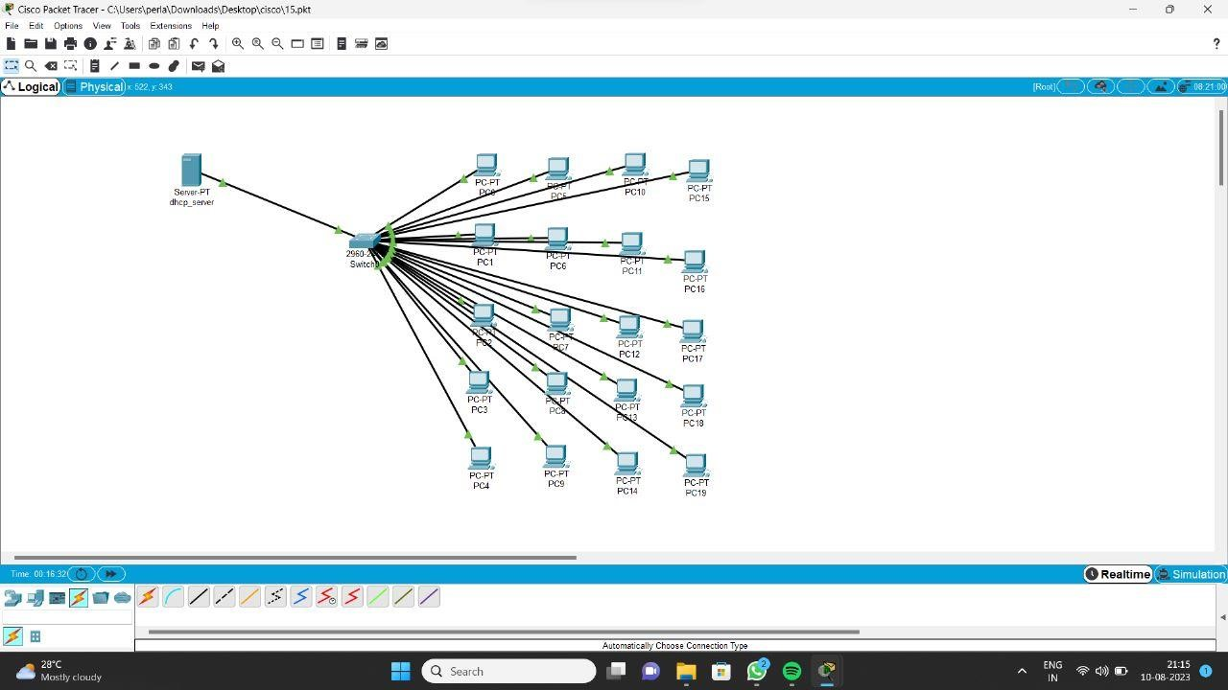

Simulate a Multimedia Network

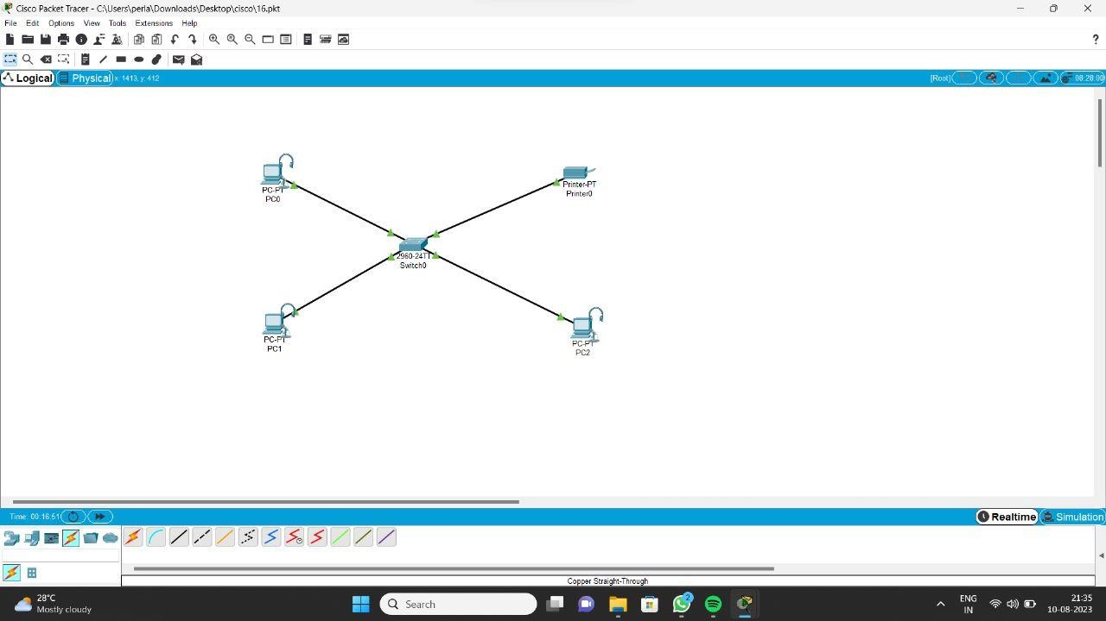

AAA Local & Server Based Authentication Configuration

in Cisco Packet Tracer

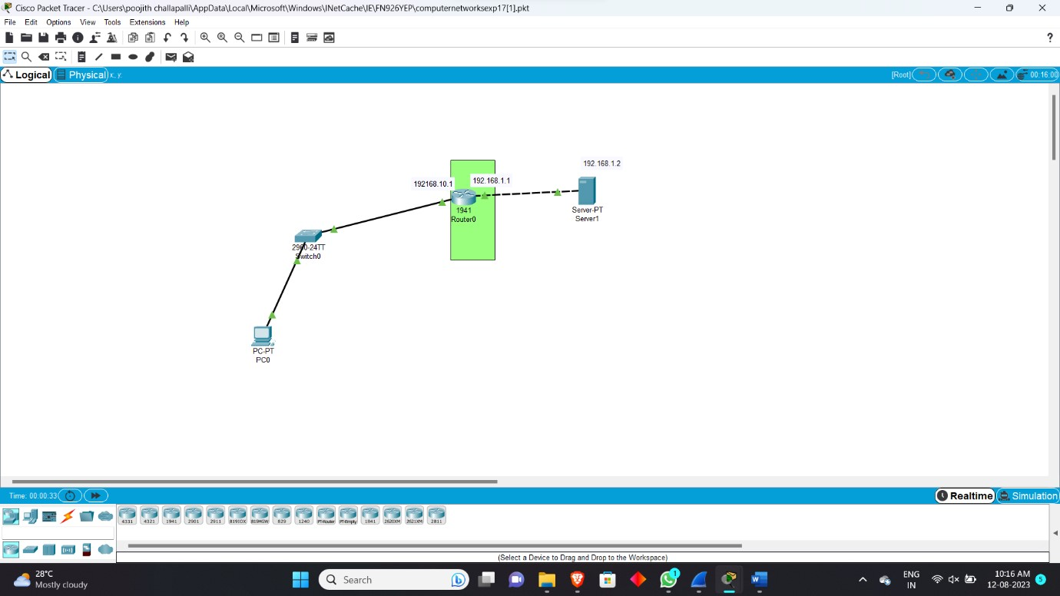

**:-** IOT Based Smart Home using WPA Security & Radius Server

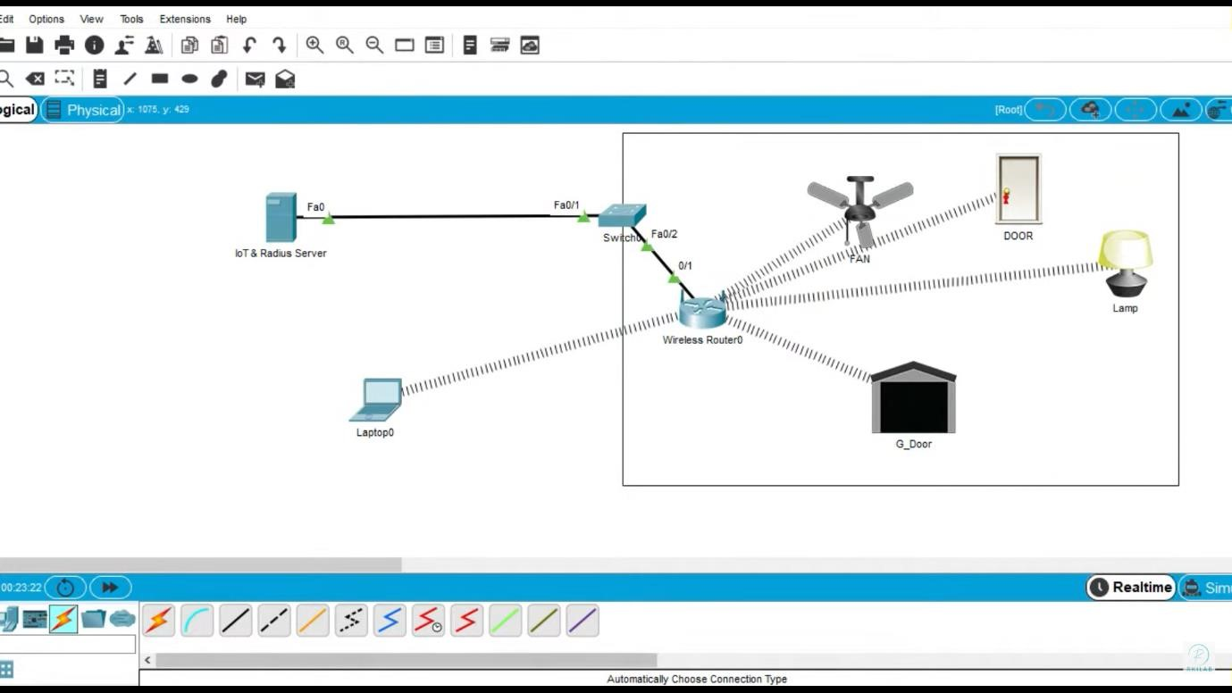

**Experiment -19 :-** WLAN Using Cisco Packet Tracer

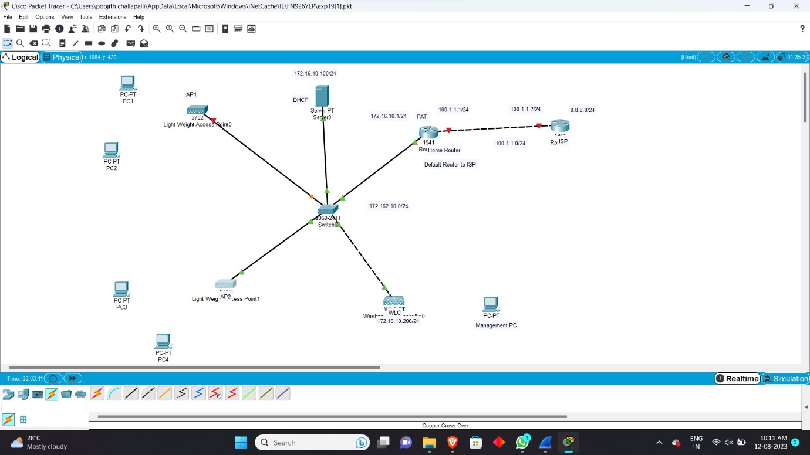

**Experiment -20 :-** Control of Fan, Light, Window & Application of Using Cisco Packet Tracer

